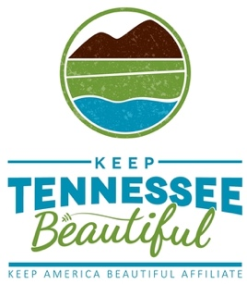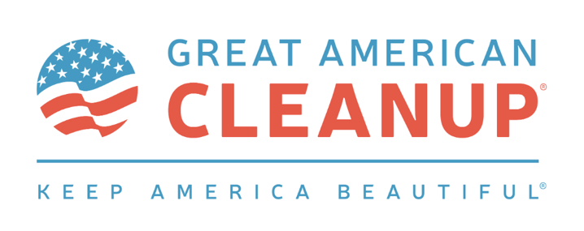

For Immediate Release: March 5, 2024
Contact: Cindy Dupree Holloway
Cindybdupree@gmail.com
615-838-9616

UNICOI COUNTY’S KAREN DUNLAP RECEIVES
2024 LOVE WHERE YOU LIVE AWARD
Keep Tennessee Beautiful Executive Director Missy Marshall Makes Presentation

MEMPHIS, Tenn. (March 5, 2024) – Karen Dunlap, president of Keeping the Valley Beautiful in Erwin, Tenn., was honored with Keep Tennessee Beautiful’s Love Where You Live Award. KTnB Executive Director Missy Marshall made the presentation during the 2024 Keep Tennessee Beautiful Month and Great American Cleanup Kick-off event, held at Conservation Hall at the Tennessee Governor’s Residence in Nashville.

“It’s such an honor to receive this award from Keep Tennessee Beautiful,” Dunlap said. “I truly believe if we all do our part, we can make a huge impact in our communities. It’s a great cause, so let’s all join the anti-litter initiative in Tennessee."
Since serving as president of Keeping the Valley Beautiful’s Board of Directors, Karen Dunlap has led the organization in major educational and cleanup events, collaborating with government officials, educators, civic groups, environmental groups, the media and others to help accomplish the mission of KVB. A born leader, Karen inspires the community to engage in volunteerism and promote litter free, reduce, reuse, and recycle concepts.
“Karen Dunlap is a persistent and positive force in achieving the goals of Keeping the Valley Beautiful,” Marshall said. “Karen's creative energy brings people together. I’m so glad she has chosen to help lead the fight against litter in this breathtakingly beautiful area of our state.”
As an officer and nurse in the United States Army, Karen honed her skills in organization, leadership, collaboration and, most importantly, caring. Among the highlights of the past two years under Dunlap’s direction is a 30% increase in KVB memberships, launch of the Youth Education Through Engagement Program, the YMCA After School Program, and United Way Relay for Life, among many other initiatives. She sees engaging the younger generation as critical to sustaining anti-litter attitudes.
Nominees for KTnB’s Love Where You Live Award were submitted from statewide Keep Tennessee Beautiful affiliates. Criteria required nominees be involved in projects, programs and leadership efforts that have impacted their community in a positive, unique way. All submissions included examples of how each leader went above and beyond their job description to help educate and inspire Tennesseans to take care of their community environment.
Keep Tennessee Beautiful Month and the Great American Cleanup help accomplish the mission of KTnB: to educate and inspire Tennesseans to take action every day to improve and beautify their community environment.
For more information, visit https://www.keeptnbeautiful.org/

###
About Keep Tennessee Beautiful:
Keep Tennessee Beautiful is the state level affiliate of Keep America Beautiful and serves as a state resource for litter prevention, community greening, and recycling & waste reduction education.
Keep Tennessee Beautiful is a grant-funded organization sponsored by the Tennessee Department of Transportation as a community engagement program at The University of Memphis – Center for Regional Economic Enrichment.

